**Introduction to Enterprise Analytics**

# ALY6050 Module 5 Assignment

# Faculty: Prof. Richard He

# 2020 Winter CPS Quarter

# Image result for neu cps

Shraddha Gopalakrishnan [NUID: 001376444]

**Introduction**

Optimization is a part of our daily life; from finding the fastest route to college, packing a suitcase for a long vacation to planning workouts for maximum impact in the least timeframe are few of the optimization problems that we unknowingly solve every day. One of the simplest techniques utilized in the statistical and math world is Linear Programming which is reviewed in this module. Linear Programming is an optimization model in which a linear function is maximized or minimized based on few norms to find most favorable data point. Many large distribution companies make use of linear programming in the analysis of their supply chain operations; over which this assignment is based. [1]

**Analysis**

Like any other linear program problem, we first examine the mathematical formulation of the business scenario with objective functions and constraints. In the analysis, we try to examine the profits by maximizing the data with conditions based on budget, space, and criteria on resource allocation and quantities sold. The study is stationed in both Excel and RStudio.

Derivations based on required assumptions:

***Excel:***

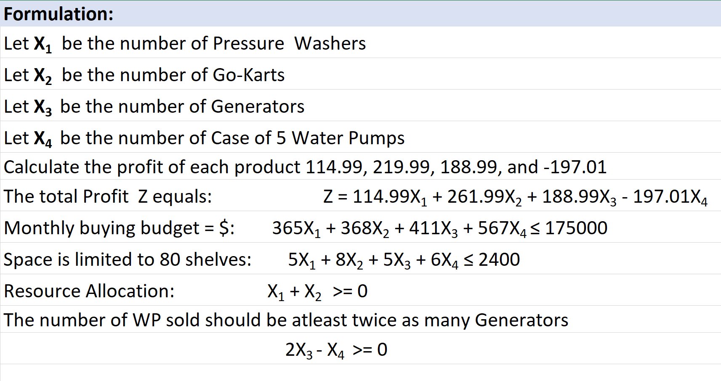Profits are found by the formula Selling Price - Cost Price. These are the coefficients for 4 products in our objective function. The monthly budget is the cost price and the company has set the purchasing monthly budget as 175000. Only considering the length of the space in feet we assign the coefficients for space conditions. 33% of the quantities which help in profit are earmarked for Pressure Washers and Go-karts. Lastly, the number of Water pumps should be at least twice as many Generators.

Figure : Formulation in Excel

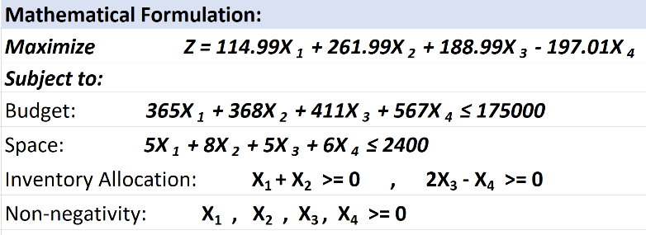

Figure :Mathematical Formulation

The image besides is our linear programming model - ***LPP model***.

***RStudio:***

In R, we write the following code to install linear programming packages:

install.packages("lpSolve")

require("lpSolve")

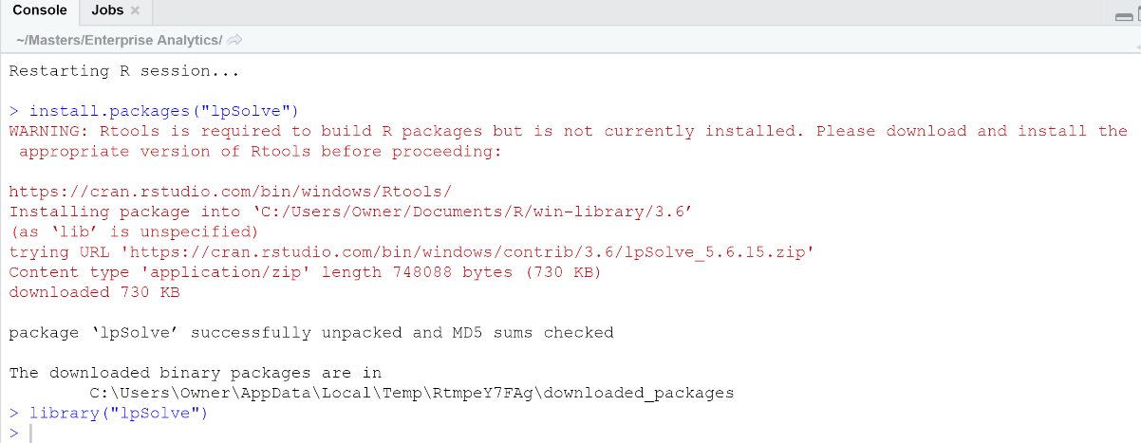

Figure : R code for installing Linear Programming package

Next we define our decision variables (mathematical formulation in Excel)-

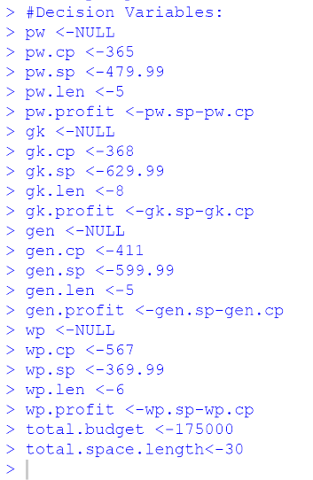

Figure : Initializing Decision Variables

The four products with their cost price, selling price, space in terms of length occupied and profit values are defined. Next we enter:

total.budget <-175000

total.space.length<-30

Excel Solver is used to solve our linear problem:

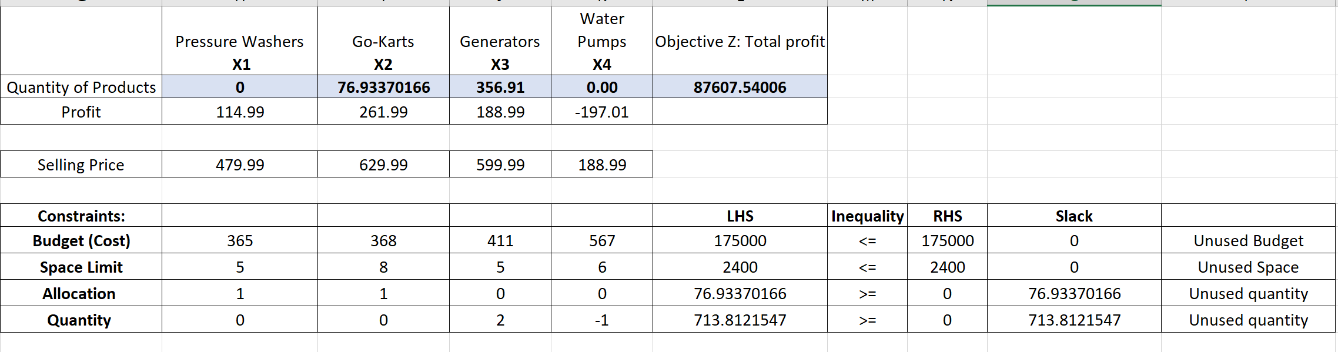The solution measured are portrayed which can be compared with the evaluation in R.

Figure : Excel Solver Output

**“z” is just the name of our maximization object**

Seting the Coefficients of decision variables-

z.obj <- c(pw.profit, gk.profit, gen.profit,wp.profit)

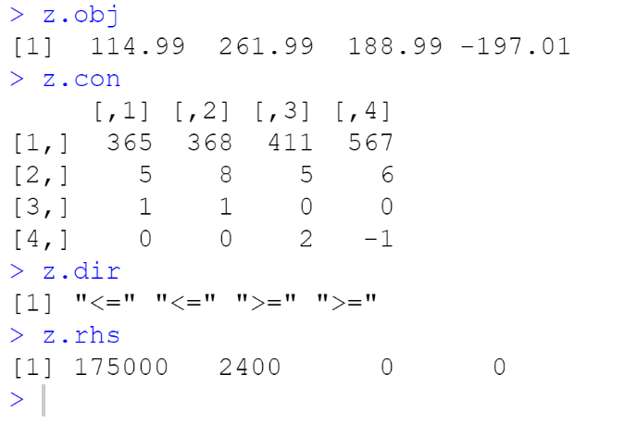z.obj

Figure : Fixing Coefficients of Constraints

Setting the coefficients of constraints in the matrix-

z.con <- matrix (c(pw.cp, gk.cp, gen.cp, wp.cp, pw.len, gk.len, gen.len, wp.len, 1, 1, 0, 0, 0, 0, 2, -1), nrow=4, byrow=TRUE)

z.con

Inequality symbol of the constraints-

z.dir <- c("<=", "<=", ">=", ">=")

z.dir

Right hand side of the equation-

z.rhs <- c(175000, 2400, 0, 0)

z.rhs

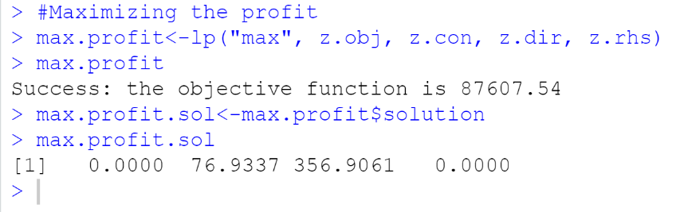Solution Obtained:

Figure : Maximize the profits of hardware company

max.profit<-lp("max", z.obj, z.con, z.dir, z.rhs)

max.profit

max.profit.sol<-max.profit$solution

max.profit.sol

The ***Inventory level*** for all 4 products are:

Pressure Washer- 0, Go-kart- 76.9337, Generator- 356.9061, Water Pumps-0

The ***Optimal Monthly Profit*** is $87607.54.

***Sensitivity Analysis:*** *Provides us with upper and lower limit values for described linear problem. It is a report which shows up as a financial model determining how target variables are affected based on changes in input variables.*[1]

The objective function limits are derived from the below lines:

lp ("max", z.obj, z.con, z.dir, z.rhs, compute.sens=TRUE)$sens.coez

lp ("max", z.obj, z.con, z.dir, z.rhs, compute.sens=TRUE)$sens.coez.from

lp ("max", z.obj, z.con, z.dir, z.rhs, compute.sens=TRUE)$sens.coez.to

The output is NULL for all the three which denotes the values for the variables and constraints will remain unchanged as long as the objective coefficient is 0.

The Dual values with from and till limits-

lp ("max", z.obj, z.con, z.dir, z.rhs, compute.sens=TRUE)$duals

lp ("max", z.obj, z.con, z.dir, z.rhs, compute.sens=TRUE)$duals.from

lp ("max", z.obj, z.con, z.dir, z.rhs, compute.sens=TRUE)$duals.to

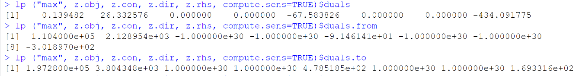

The dual values are given both for constraints and variables. The **constraint Budget** has a dual value of 0.139482 which specifies how much the objective function will vary if the constraint value is incremented by one unit. It varies from 1.104000e+5 to 1.972800e+5. This implies that there is only a non-zero dual value if the constraint is active. The **constraint Space Limit** has a value 26.332576 until the objective function is between 2.128954e+03 and 3.804348e+03. [2]

*Note: If the dual value is very high, then this constraint is very influential on the objective function and if we can change it a bit then the solution will be much better. Also, the sign of the dual value has a meaning. A positive value means that as the restriction becomes larger, the objective value will be larger, and as it becomes more negative, the objective value will be smaller.*

***Closures:***

5. The smallest selling price value is $110400 obtained from duals. from solution.

6. In addition to the $175,000 the company should not allocate additional money during the first month as the maximized profit comes to $87607.54 which is already lower than the company’s purchasing monthly budget.

7. The company should rent a smaller warehouse as 76.933sqft is shown as slack in excel which means unused allocation constraint. The ideal size should be (2400-76.933) 2323.067sqft and this change will not contribute to the monthly profit of the hardware company.

**Conclusion**

Linear programming problem is an important technique which enables higher officials of a company to arrive at proper decisions regarding raised questions. With the help of LPP, the company’s budget has been allocated and limited budget problem has been solved. The sensitivity report helps in deciding future marketing strategies. [2] The dual values in the sensitivity report indicate that the objective function value tends to be the same in either case of maximizing or minimizing the solution. We successfully found an optimal solution with a feasible set of data points. It is by far the most widely used method to solve such statistical-oriented problems. Only rarely are its limitations encountered in practical applications or in real-world. The biggest advantage of this technique is that it always achieves the optimal solution if one exists.

**References**

[1] Carmo-Neto, D. (2015, April 28). LP linear programming (summary) (5s).https://www.slideshare.net/DionsioCarmoNeto/lp-linear-programming-summary-5s

[2] Singh, H. (2018, December 1). Using Analytics for Better Decision-Making. Retrieved from <https://towardsdatascience.com/using-analytics-for-better-decision-making-ce4f92c4a025>